

MINI PROJECT REPORT
ROCK PAPER SCISSORS C PROGRAM
SUBMITTED BY
NAME | PRN
Bhagyawan Vanave | 1262253821
Purab Rupesh Agarwal | 1262252503
Archit Shinde | 1262252570
Anish Nemade | 1262253681
Subhod Dharmapatre | 1262251582

Introduction
Rock Paper Scissors is a classic hand game traditionally played between two participants, where each player simultaneously selects one of three possible options: Rock, Paper, or Scissors. The outcome is determined based on predefined rules: Rock defeats Scissors, Scissors defeats Paper, and Paper defeats Rock. Despite its simplicity, the game provides an excellent platform for implementing and understanding fundamental programming concepts.
In this project, we have developed a console-based Rock Paper Scissors game using the C programming language. The primary objective of this project is to design and implement an interactive game where the user competes against the computer. The program utilizes structured programming principles and incorporates decision-making logic to simulate real gameplay conditions.
The system works by accepting user input through the keyboard and generating the computer’s choice using pseudo-random number generation. The srand(time(0)) function is used to seed the random number generator, ensuring that different results are produced each time the program runs. The rand() function is then used to generate values corresponding to Rock, Paper, or Scissors. The program compares both choices using conditional statements (if-else) to determine the winner based on standard game rules.
To enhance interactivity, the game is executed within a loop structure, allowing multiple rounds to be played. Score variables are maintained to track the number of wins for both the user and the computer. After a predefined number of rounds, the program evaluates the final scores and declares the overall winner. Input validation mechanisms are also implemented to handle invalid user entries, thereby improving program robustness.
This project demonstrates the practical application of several core programming concepts, including:
- Data types and variable declarations
- Control structures (if–else, loops)
- Arrays for storing choices
- Random number generation
- Input and output operations (printf, scanf)
- Logical operators and comparison expressions
- Program flow control and algorithm design
From a technical perspective, this project reinforces the understanding of procedural programming and modular problem-solving. It highlights how algorithm design, flowchart representation, and structured coding techniques are combined to develop a functional and interactive application in C.
Overall, the Rock Paper Scissors game project serves as an effective demonstration of foundational programming principles and provides hands-on experience in building real-world logical applications using the C language.

Libraries Used in the Project
In this Rock Paper Scissors game project, three standard C libraries are used to perform input/output operations, random number generation, and time-based initialization. Each library plays an important role in making the program functional and interactive.

1. stdio.h (Standard Input Output Library)
The stdio.h library is used for performing input and output operations in C. It allows the program to interact with the user through the console.

Functions Used:
- printf() – Displays output on the screen.
- scanf() – Accepts input from the user.

Role in the Project:
In this project, printf() is used to display:
- Game instructions
- Menu options (Rock, Paper, Scissors)
- Computer’s choice
- Round results
- Final scores
The scanf() function is used to take the user’s choice as input during each round. Without this library, user interaction would not be possible.

2. stdlib.h (Standard Library)
The stdlib.h library provides various utility functions, including memory management, conversions, and random number generation.

Functions Used:
- rand() – Generates a pseudo-random number.
- srand() – Seeds (initializes) the random number generator.

Role in the Project:
In this game, rand() is used to generate the computer’s choice randomly. Since the game requires the computer to select Rock, Paper, or Scissors unpredictably, random number generation is essential.
The expression:
(rand() % 3) + 1
ensures that the computer generates a number between 1 and 3, representing:
- 1 → Rock
- 2 → Paper
- 3 → Scissors
The srand() function ensures that different random values are generated each time the program runs.

3. time.h (Time Library)
The time.h library is used to work with date and time functions in C.

Function Used:
- time(0) – Returns the current system time.

Role in the Project:
The function time(0) is used inside srand() as:
srand(time(0));
This seeds the random number generator using the current system time. Since system time changes every second, it ensures that the random numbers generated by rand() are different every time the program is executed.
Without time.h, the computer would generate the same sequence of random numbers every time the program runs, making the game predictable.

ALGORITHIM
1.Start
2.Declare variables:
user, computer
round = 1
userScore = 0
compScore = 0
3.Create an array choices[] containing:
"Rock", "Paper", "Scissors"
4.Initialize the random number generator using srand(time(0))
5.Display the game instructions
6.Repeat the following steps while round <= 5:
a) Display the current round number
b) Accept user input
c) If input is invalid:
Display error message
Clear input buffer
Continue to next iteration
d) Generate computer choice using rand() % 3
e) Display both user and computer choices
f) Compare the choices:
If both are same → Declare Draw
If user satisfies winning condition →
Increment userScore
Otherwise →
Increment compScore
g) Increment round
7.After completing 5 rounds, display final scores
8.Compare final scores:
If userScore > compScore → Declare User Wins
If compScore > userScore → Declare Computer Wins
Otherwise → Declare Game Draw
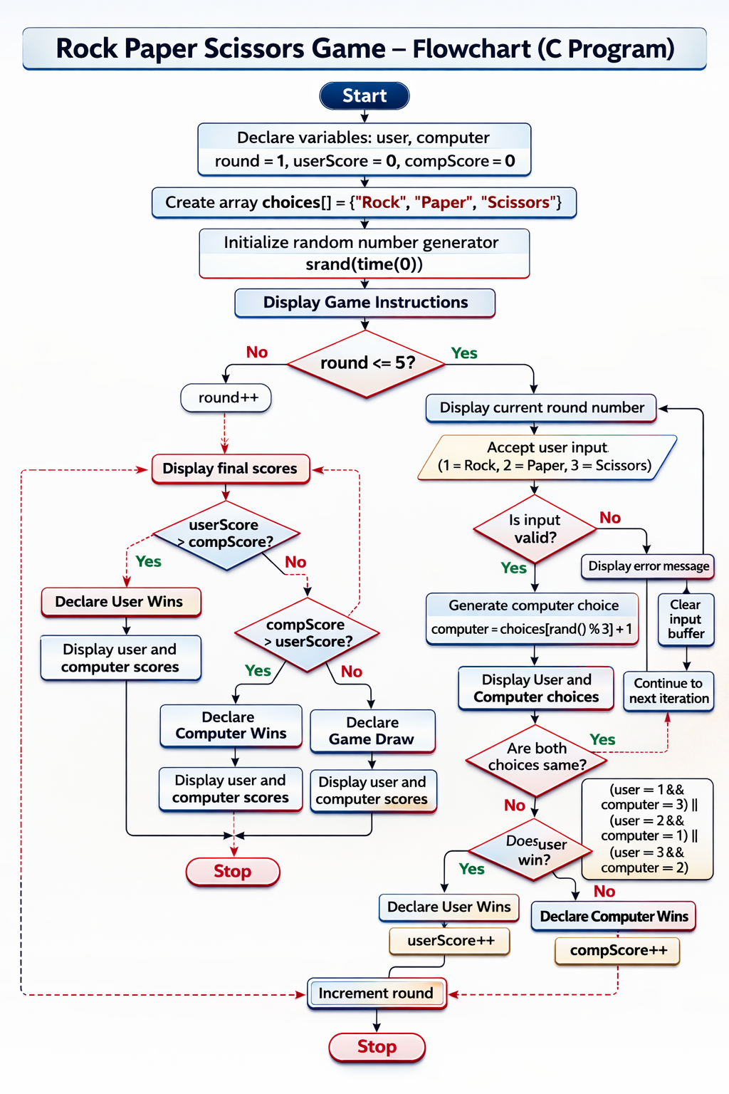

1) Line-by-Line Explanation of the Code

Header Files
#include <stdio.h>
Used for standard input and output functions like printf() and scanf().
#include <stdlib.h>
Used for random number generation functions rand() and srand().
#include <time.h>
Used for the time() function to seed the random number generator.

Main Function
int main()
Program execution starts from the main() function.

Variable Declaration
int user, computer;
Stores the numeric choices of the user and computer (0, 1, or 2).
int round = 1;
Tracks the current round number. Initialized to 1.
int userScore = 0;
int compScore = 0;
Stores total wins of the user and computer.

Array of Choices
char *choices[] = {"Rock", "Paper", "Scissors"};
An array of string pointers storing the names of choices.
If user = 1, then choices[1] prints "Paper".

Random Seed
srand(time(0));
Initializes random number generator using current system time so results differ every run.

Game Instructions
printf("=== Rock Paper Scissors Game ===\n");
printf("0 = Rock | 1 = Paper | 2 = Scissors\n");
Displays game title and input format.

While Loop
while (round <= 5)
Runs the game for exactly 5 rounds.
Each iteration:
- Takes input
- Validates input
- Generates computer choice
- Compares results
- Updates score
- Increments round

Why We Used While Loop?
We used while because:
It checks the condition before execution
It clearly expresses "run while round ≤ 5"
It gives flexible control over the round counter

Why Not for Loop?
A for loop could also be used:
for(round = 1; round <= 5; round++)
But we used while because:
- It is conceptually clearer for beginners
- It separates round increment logic
- It gives more flexibility if logic becomes dynamic later

Why Not do while Loop?
do-while executes at least once even if condition is false.
In our case:
- We want to check condition first.
- If round limit changes, we want proper control.
- while is more structured for round control.

Inside the Loop

Display Round
printf("\nRound %d\n", round);
Shows current round number.

Input Validation
if(scanf("%d", &user) != 1)
Checks if input is integer.
Prevents program crash if user enters text.
while(getchar() != '\n');
Clears input buffer.

Range Validation
if(user < 0 || user > 2)
Ensures user enters only 0, 1, or 2.

Why We Used if Here?
Because:
- We need to check conditions.
- We need to stop invalid input.
- Prevent logical errors.
if allows decision-based execution.

Generate Computer Choice
computer = rand() % 3;
% 3 ensures output is:
0, 1, or 2.

Display Choices
printf("You chose: %s\n", choices[user]);
printf("Computer chose: %s\n", choices[computer]);
Uses array indexing to display string representation.

scanf("%d", &user) != 1
- scanf() reads user input.
- %d expects an integer.
- scanf() returns the number of successfully read inputs.
If the user enters:
- 1 → It reads successfully → returns 1
- abc → It fails → returns 0
So,
scanf("%d", &user) != 1
means:
"If the input is NOT a valid integer"

2️ Error Message
printf("Invalid input! Enter 0, 1, or 2 only.\n");
Displays an error message to guide the user.

3️ Clearing Input Buffer
while(getchar() != '\n');
This is very important.
When a user enters invalid input like:
abc
The invalid characters remain in the input buffer.
If we do not clear it:
- The program will repeatedly read the same invalid input.
- It may go into an infinite loop.
getchar() reads one character at a time until newline (\n) is found.
This clears all remaining characters from the buffer.

4️ continue;
continue skips the remaining part of the loop and starts the next iteration.
This ensures:
- The program does not execute game logic.
- It directly asks the user for input again.

Result Decision Using if-else
if (user == computer)
If both choices same → Draw.

else if ((user == 0 && computer == 2) ||
(user == 1 && computer == 0) ||
(user == 2 && computer == 1))
Checks winning conditions:
- Rock beats Scissors
- Paper beats Rock
- Scissors beats Paper

else
If not draw and not user win → Computer wins.

Why We Used if-else Here?
Because:
- Only one outcome can be true.
- Conditions are mutually exclusive.
- if-else chain ensures only one block executes.
- It gives structured logical comparison.

Increment Round
round++;
Moves to next round.

Final Result Section
After loop ends:
printf("Your Score = %d\n", userScore);
printf("Computer Score = %d\n", compScore);
Displays final scores.

Decide Overall Winner
if (userScore > compScore)
User wins game.
else if (compScore > userScore)
Computer wins game.
else
Game draw.

return 0;
Indicates successful program termination.

Game Logic and Winning Conditions

How the Winner is Decided
The core logic of the Rock Paper Scissors game is implemented using if–else conditional statements. These conditional structures allow the program to compare the user’s choice with the computer’s choice and determine the result of each round based on predefined rules.
In the program, both the user and the computer select a number between 0 and 2, where:
- 0 represents Rock
- 1 represents Paper
- 2 represents Scissors
After both inputs are obtained, the program evaluates different logical conditions to determine the outcome of the round.

Possible Outcomes of Each Round
There are three possible results in every round:

1️ User Wins
If the user’s choice satisfies the winning condition against the computer’s choice, the program declares that the user wins the round and increments the user’s score.

2️ Computer Wins
If the computer’s choice satisfies the winning condition against the user’s choice, the program declares that the computer wins the round and increments the computer’s score.

3️ Draw
If both the user and the computer select the same option, the result is declared as a draw, and no score is incremented.

Why While Loop is Preferred in This Project
In this Rock Paper Scissors game, a while loop is used to control the execution of multiple rounds. The loop ensures that the game runs exactly five times, allowing the user and the computer to compete in five separate rounds before declaring the final result.
while (round <= 5)
This condition means that the game will continue executing as long as the value of round is less than or equal to 5. After each round, the round variable is incremented, eventually terminating the loop when the condition becomes false.

Reasons for Preferring While Loop

1️ Condition-Based Execution
The while loop is condition-controlled. It checks the condition before executing the loop body. This ensures:
- The loop runs only when the condition is true.
- Proper control over the number of rounds.
- No unnecessary execution.
Since the game depends on a round counter, a condition-based loop is logically suitable.

- each round.
Therefore, a while loop is more appropriate.

Why If–Else Structure is Used
The if–else structure is used because:
- It allows step-by-step logical comparison.
- It ensures only one block executes at a time.
- It is efficient for mutually exclusive conditions.
- It improves readability and maintainability of the code.
- It makes the decision-making process clear and structured.

Fairness and Accuracy of the Logic
The game logic ensures fairness because:
- The computer’s choice is generated randomly using rand() % 3.
- Each choice has an equal probability of being selected.
- The rules are applied consistently for every round.
- Scores are updated only when valid winning conditions are satisfied.
This structured logic guarantees that the game outcome is unbiased and mathematically correct.

Technical Perspective
From a technical standpoint, the game logic demonstrates:
- Conditional branching
- Boolean expressions
- Logical operators (&&, ||)
- Equality comparison (==)
- Structured flow control
- Deterministic decision-making process
The implementation ensures efficient execution while maintaining simplicity and clarity.

Conclusion Section (For Report)
The Rock Paper Scissors game project successfully demonstrates the practical implementation of fundamental C programming concepts. Through this project, we applied conditional statements, loops, arrays, random number generation, and input validation techniques to create a fully functional interactive application.
The program effectively simulates real-world gameplay between a user and the computer while maintaining fairness through randomization. It enhances understanding of control flow, logical decision-making, and structured programming design.
Overall, this project strengthens problem-solving skills and provides hands-on experience in building console-based applications using the C programming language.

Uses stdio.h, stdlib.h, time.h

Uses array of strings for choices

Uses while loop for 5 rounds

Has proper input validation

Uses logical conditions for winning rules

Tracks scores

Displays final result

Clean structure and readable comments

